**Supplementary figures for Mervine et al. – Biomass carbon emissions from nickel mining have significant implications for climate action**

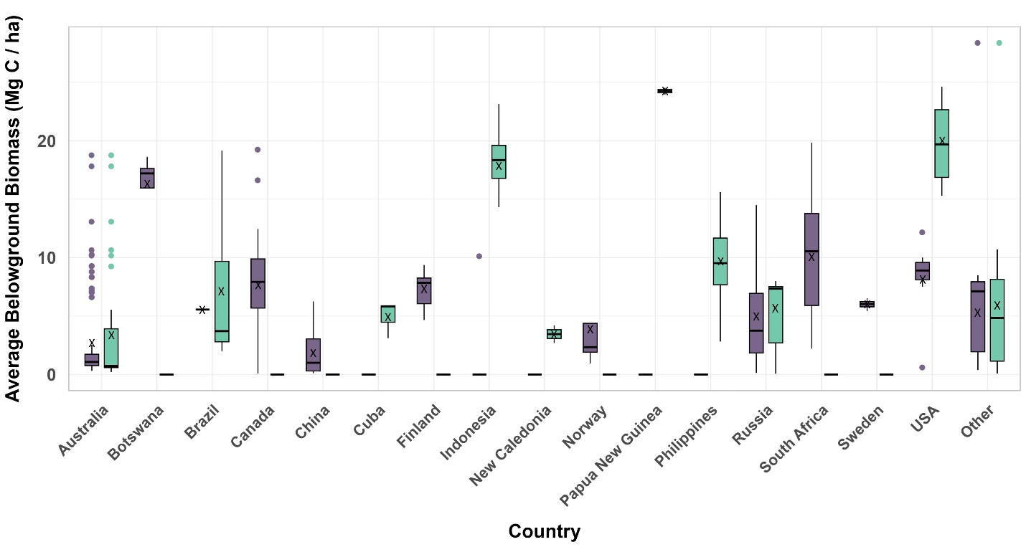

Fig. S1. Belowground biomass carbon densities (Mg C/ha) for undeveloped nickel deposits. The carbon biomass densities are the average values from the Spawn *et al.* dataset within 5 km radius circles around the coordinates of the deposits. Sulfide deposits are shown in purple while laterite deposits are shown in turquoise. The box-and-whisker plots show the mean (x), median (line), and upper and lower quartiles (whiskers). If there are any statistical outliers, these are shown as dots above or below the whiskers.

Fig. S2. Sensitivity analysis comparing biomass carbon density calculations (including aboveground and belowground biomass) for 1 km and 5 km (A) and 5 km and 10 km (B) buffers for magmatic sulfide nickel mines.

**Fig. S3.** Sensitivity analysis comparing biomass carbon density calculations (including aboveground and belowground biomass) for 1 km and 5 km (A) and 5 km and 10 km (B) buffers for laterite nickel mines.

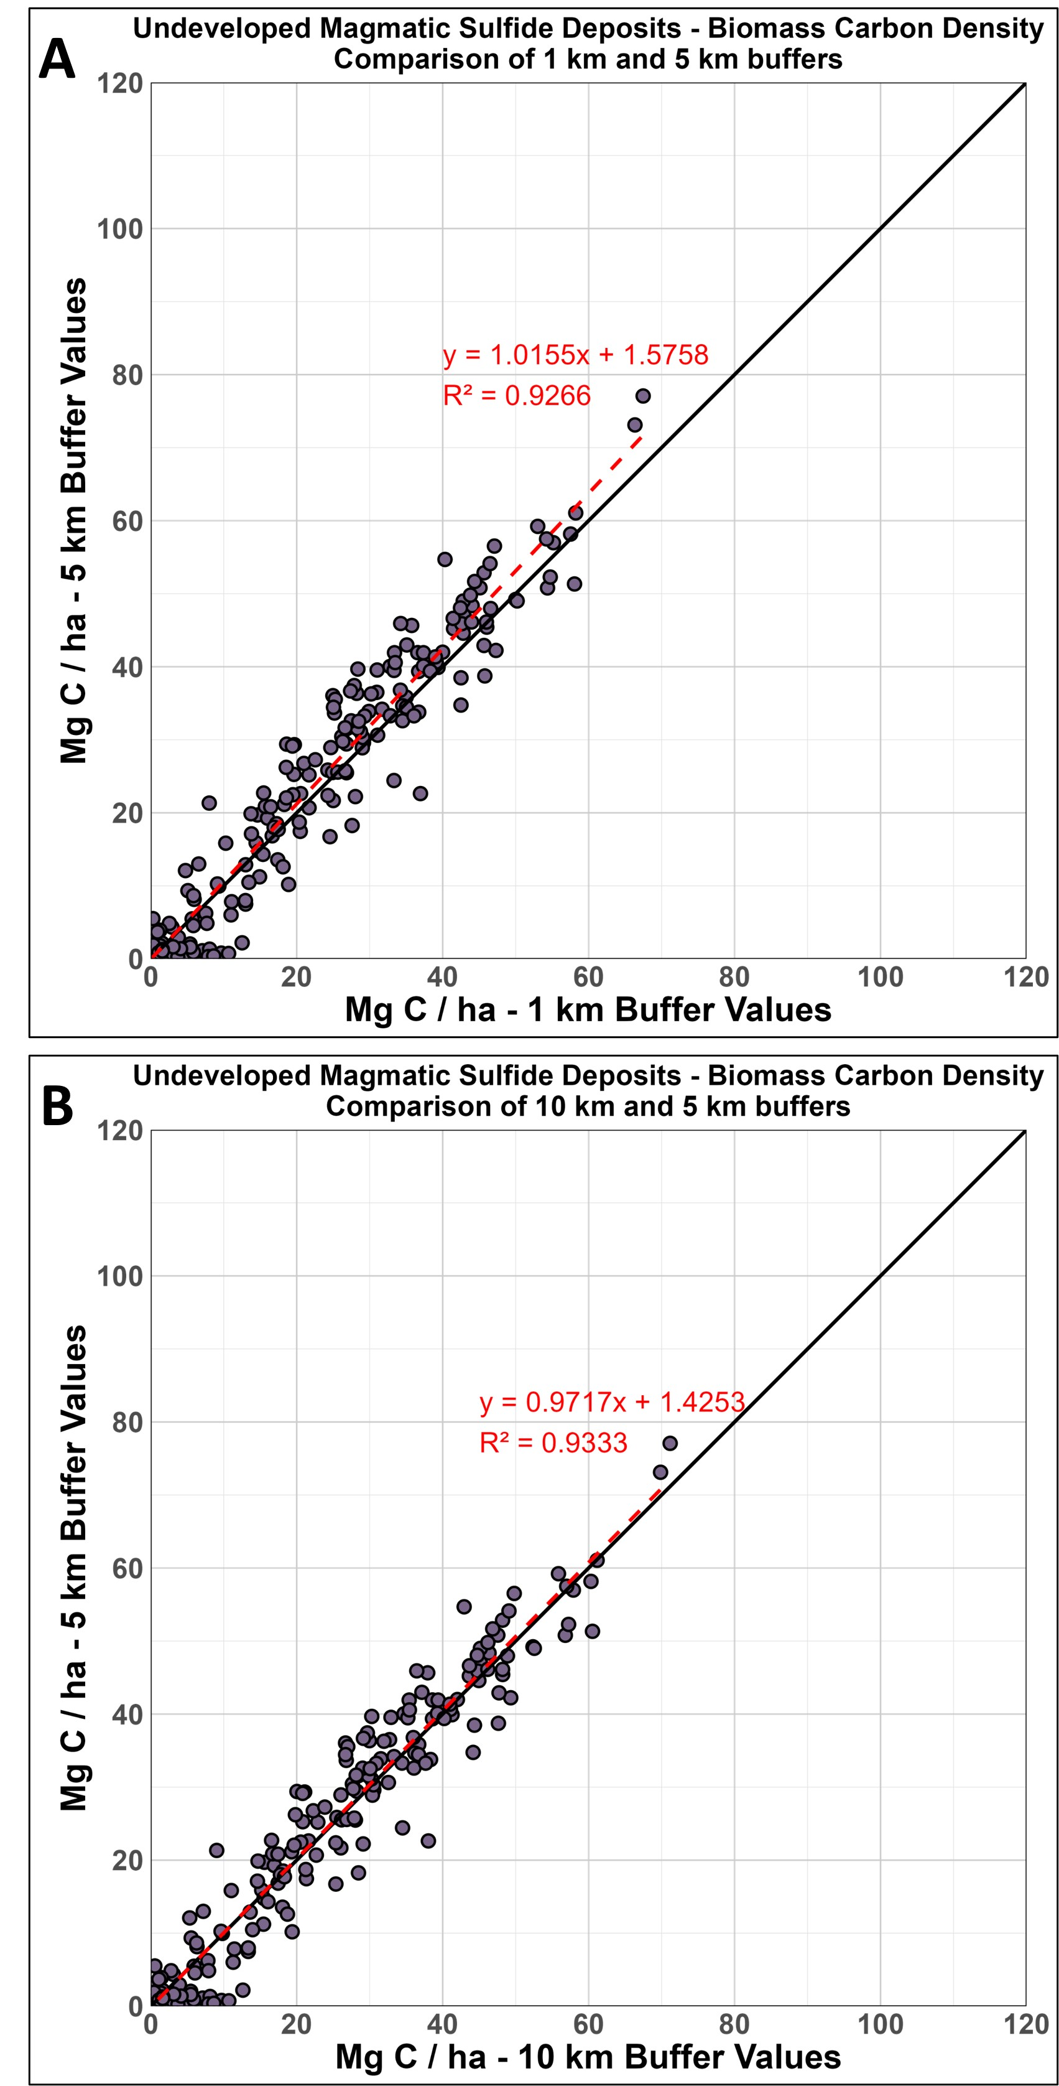

**Fig. S4.** Sensitivity analysis comparing aboveground biomass carbon density calculations (including aboveground and belowground biomass) for 1 km and 5 km (A) and 5 km and 10 km (B) radius buffer circles for undeveloped magmatic sulfide deposits.

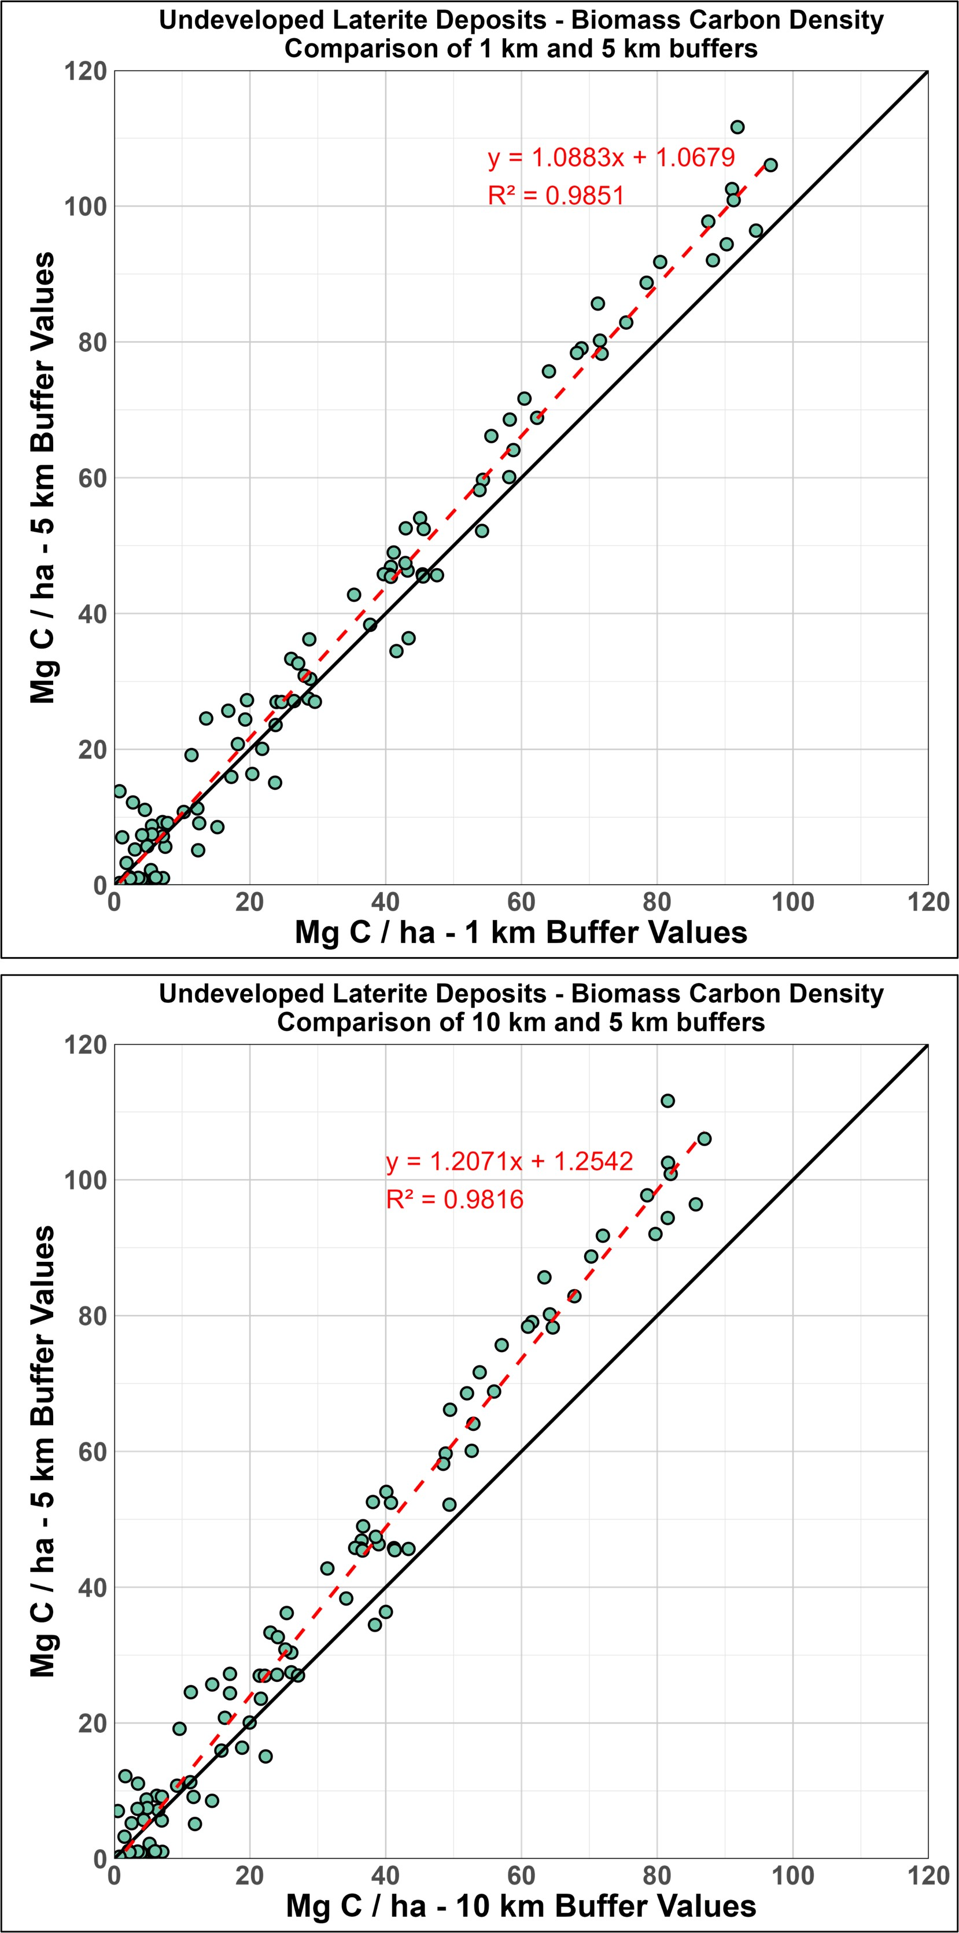

Fig. S5. Sensitivity analysis comparing belowground biomass carbon density calculations (including aboveground and belowground biomass) for 1 km and 5 km (A) and 5 km and 10 km (B) radius buffer circles for undeveloped laterite deposits.

**Fig. S6**. Flowchart of multilevel weighted mean calculation to address the uncertainties inherent in biomass estimation, accounting for variability across land cover types. Squares represent the layers produced and ovals represent the process.

**Fig. S7.** Uncorrected calculation of impact of nickel mining on land and biomass carbon.Sulfide mines are shown in purple and laterite mines are shown in turquoise. Individual mines are shown as circles, while estimates for the major mining fields of Sudbury Basin (approximately 11 mines) and New Caledonia (approximately 30 mines) are shown as triangles. (**A**) Cumulative nickel production versus total land disturbance. (**B**) Cumulative nickel production versus average aboveground biomass densities in 5 km buffers around the mining sites. See Methods for more information on how the average biomass densities were determined. (**C**) Cumulative nickel production versus estimated total biomass carbon losses.

**Fig. S8.** Uncorrected calculation of aboveground and belowground biomass carbon densities (Mg C/ha) for undeveloped nickel deposits. The carbon biomass densities are the average values from the Spawn *et al.* dataset within 5 km radius circles around the coordinates of the deposits. Sulfide deposits are shown in purple while laterite deposits are shown in turquoise. The box-and-whisker plots show the mean (x), median (line), and upper and lower quartiles (whiskers). If there are any statistical outliers, these are shown as dots above or below the whiskers. (**A**) Comparison of aboveground biomass carbon densities for all undeveloped sulfide deposits and all undeveloped laterite deposits. (**B**) Comparison of belowground biomass carbon densities for all undeveloped sulfide deposits and all undeveloped laterite deposits. (**C**) Aboveground biomass carbon values for undeveloped sulfide and laterite deposits by country.

**Fig S9** Uncorrected belowground biomass carbon densities (Mg C/ha) for undeveloped nickel deposits. The carbon biomass densities are the average values from the Spawn *et al.* dataset within 5 km radius circles around the coordinates of the deposits. Sulfide deposits are shown in purple while laterite deposits are shown in turquoise. The box-and-whisker plots show the mean (x), median (line), and upper and lower quartiles (whiskers). If there are any statistical outliers, these are shown as dots above or below the whiskers.

**Fig. S10.** Uncorrected calculation of potential biomass carbon storage losses for undeveloped nickel deposits. The lines represent individual deposits and show how the t CO2e/t nickel changes as the land transformation factor increases from 0 to 200 m2/t nickel. The higher the biomass carbon density at the deposit location, the steeper the slope of the line. (**A**) Potential biomass carbon storage losses for undeveloped magmatic sulfide deposits. Reference lines are shown for generic land transformation factors for underground and open pit mines from the Nickel Institute, as well as for Norilsk-Talnakh and Kevitsa nickel mines (this study). (**B**) Potential biomass carbon storage losses for undeveloped laterite deposits. Reference lines are for the generic land transformation factor for open pit mines from the Nickel Institute, as well as for Murrin Murrin and Ambatovy nickel mines (this study). Note that there are no underground laterite mines.